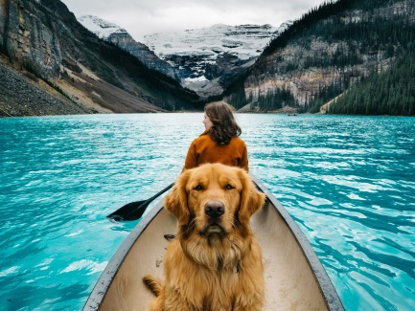

Tips for Safe Boating with Your Pet
- Collar with ID Tag and Microchip: Before heading out on the water, make sure your pet has a collar with an identification tag. Include contact information, marina address and slip number. A microchip is a permanent form of idea which is wonderful in case the collar is removed or comes off.
- Familiarization with Boat: It is best to gradually introduce your pet to your boats and water. Let your pet explore the boat while it is docked before going out on the water. Turn on the engine and let them get used to its sound and smell while the boat is docked. Then, take your pet out on small cruises and gradually build up to longer cruises.
- Safe & Easy Boat Access: Provide a ramp for your pet to get on and off the boat. This not only includes from the dock to the boat but also from the water to the boat. Pets weigh much more wet than dry and it can be very difficult to lift them back into your boat after a swim.
- Pet Life Jacket: A personal floatation device (PFD) can also ensure safety while on the water. Not all pets can swim (including some dogs). Even if your pet is a good swimmer, getting tossed overboard can put any animal into a panic. In addition, your pet could suffer from exhaustion or hypothermia. Many pets also fall into the water from the dock or while trying to get from the dock to the boat. Having your pet equipped with a floatation device with a lifting handle makes retrieving your pet much easier and safer. Help your pet get used to the PFD by first practicing at home for short periods of time. Start by putting the PFD on your pet and let them walk around with it on. The next step is to let your pet swim with it on for a short period. It's a new experience for them so it's important for them to get used to it before the boat trip.
- Proper Hydration & Staying Cool: Pets do not sweat, so keep an eye out for heavy panting or drool and a rapid heartbeat. Protect pets from heat by providing some shade on the boat, providing plenty of water and keeping the deck cool to protect paw pads. Bring along a travel water bowl and fresh water. It is critical to hydrate pets before they get into the water.
- Allow of Potty Breaks: A big challenge of boating with your pet is making provisions so that they can go to the bathroom. Bringing along your cat's litter box and securing it inside the cabin is good solution for your feline friends. Dogs, however, are a bigger challenge. If your boat trip does not allow for regular land stops for your dog to do their business, then provisions must be made so that they can relieve themselves on the boat. A portable dog potty that simulates grass is an excellent solution. These may be purchased online or at Petco.
- Medical Records: When it is time to go ashore, there are just a few things to remember if your boating destination is a marina or place that you're not familiar with. Always keep a copy of vaccination and health records. Some places may require proof of immunization before letting pets explore on land. It is important to have all vaccinations current before exposing them areas inhabited by wildlife and other pets.

